

SRI LANKA INSTITUTE OF INFORMATION TECHNOLOGY

[**Enterprise Standards and Best Practices for IT Infrastructure**](http://courseweb.sliit.lk/course/view.php?id=137)

**4th Year 2nd Semester 2014**

Name:D.S.S.Dharmachandra

SLIIT ID:IT13136734

Group Number:

Practical Session: WD

Practical Number : Lab 02

Date of Submission: 30/07/2016

Date of Evaluation : _____________________

Evaluators Signature : ____________________

Introduction

 An instance is a virtual server in the AWS cloud. With Amazon EC2, can set up and configure the operating system and applications that run on an instance.

The instance is an Amazon EBS-backed instance (meaning that the root volume is an EBS volume). You can either specify the Availability Zone in which your instance runs, or let Amazon EC2 select an Availability Zone for you. When you launch your instance, you secure it by specifying a key pair and security group. When you connect to your instance, you must specify the private key of the key pair that you specified when launching your instance.

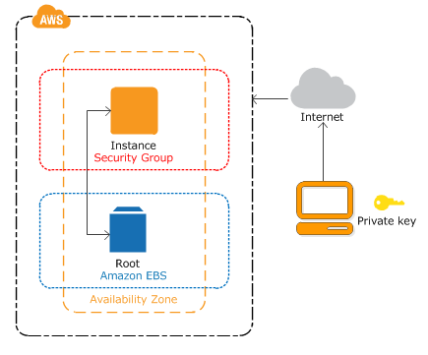

**Create a Linux instance**

* **Launch an instance**

Open the Amazon EC2 console at <https://console.aws.amazon.com/ec2/>

From the console dashboard, choose **Launch Instance**

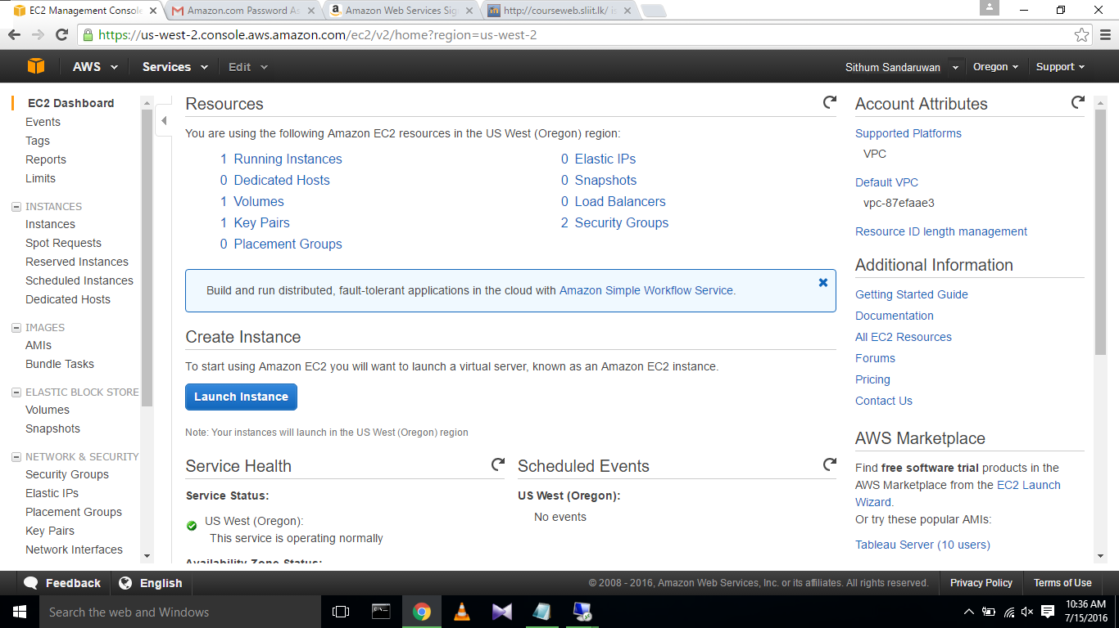

The **Choose an Amazon Machine Image (AMI)** page displays a list of basic configurations.

 Select the HVM edition of the Amazon Linux AMI.

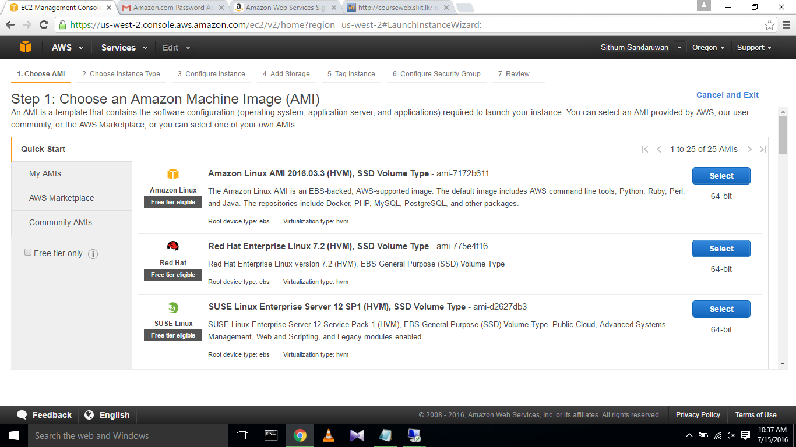

Choose **Review and Launch** to let the wizard complete the other configuration settings for you.

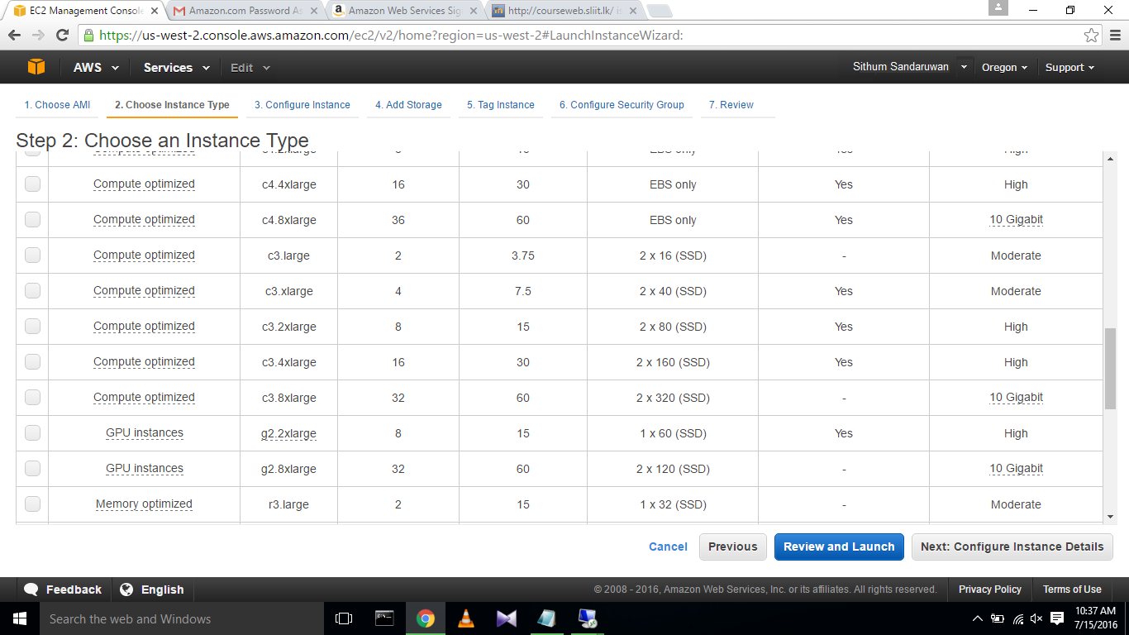

On the **Review Instance Launch** page, choose **Launch.**

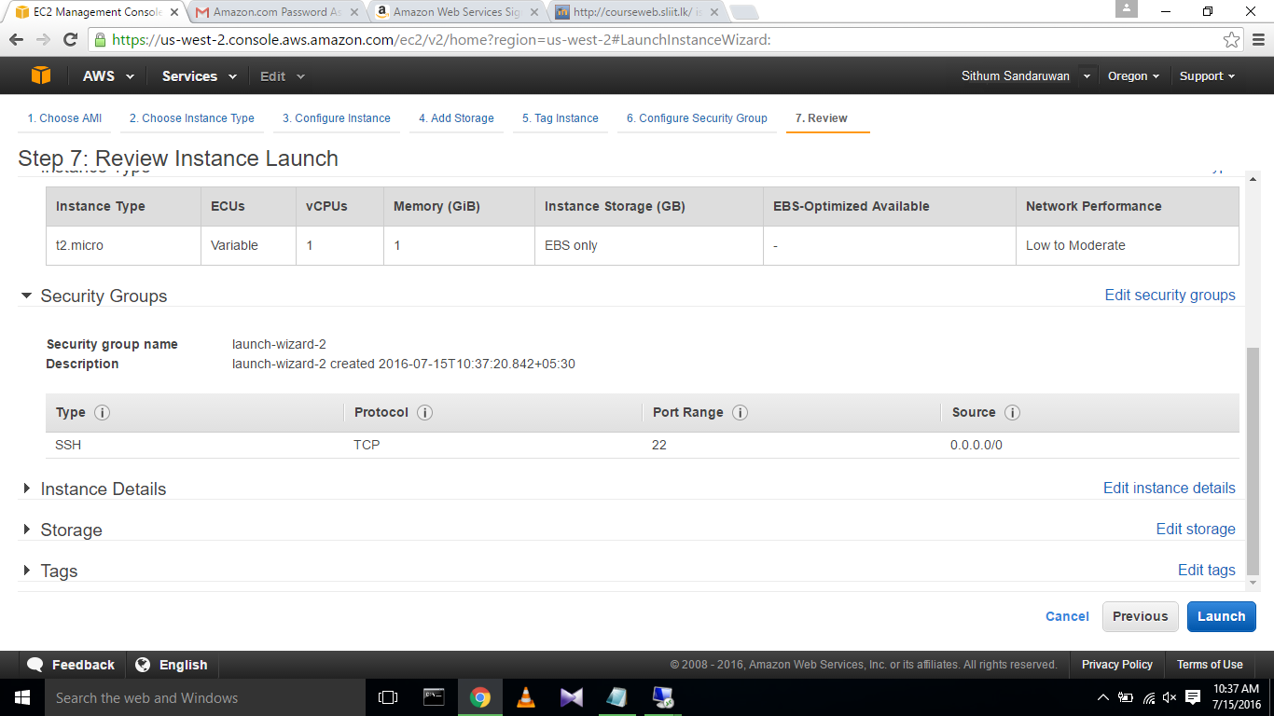

 Select **Create a new key pair**, enter a name for the key pair, and then choose **Download Key Pair**. 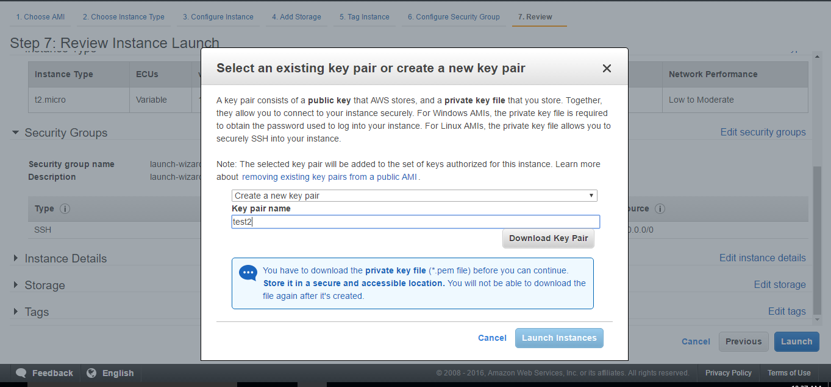

A confirmation page lets you know that your instance is launching. Choose **View Instances** to close the confirmation page and return to the console.

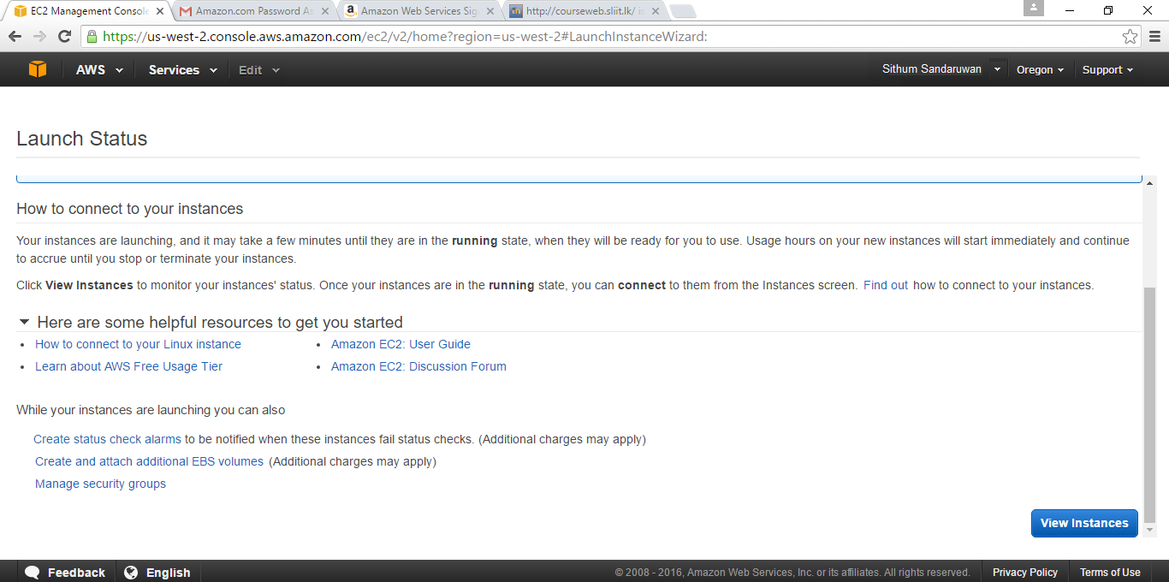

On the **Instances** screen, you can view the status of the launch. It takes a short time for an instance to launch. When you launch an instance, its initial state is pending. After the instance starts, its state changes to running and it receives a public DNS name. (If the **Public DNS** column is hidden, choose the Show/Hide icon in the top right corner of the page and then select **Public DNS**.) 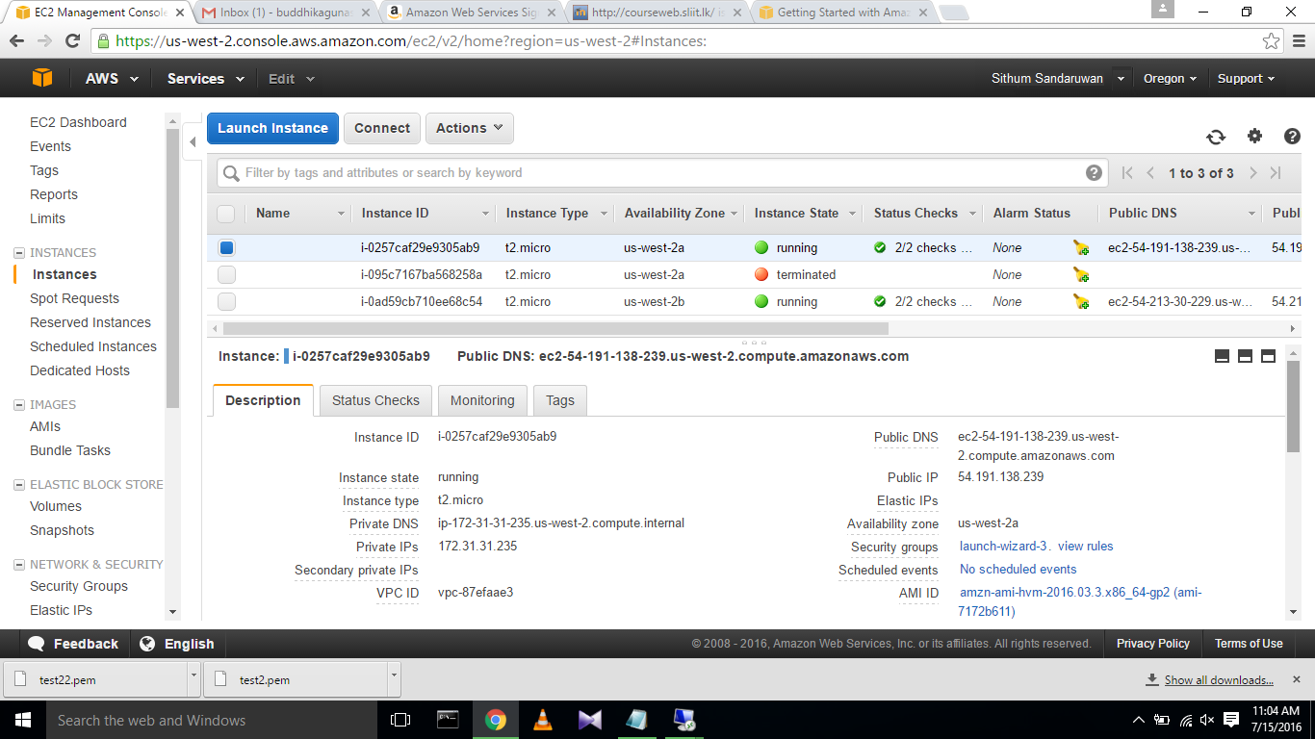

* **Connect to the Instance**

There are several ways to connect to a Linux instance. In this procedure, you'll connect using your browser. Alternatively, you can connect using PuTTY or an SSH client.

Select generate button.

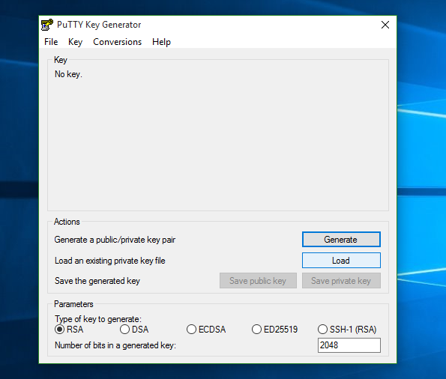

In the popup window click ok. 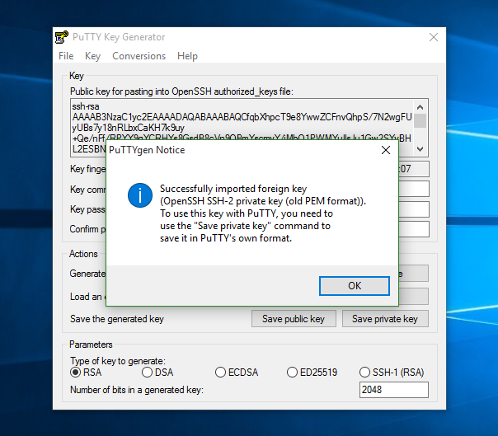

The key will appear. And to save the key select save private key button. And to the warning message, select ok to save the key.

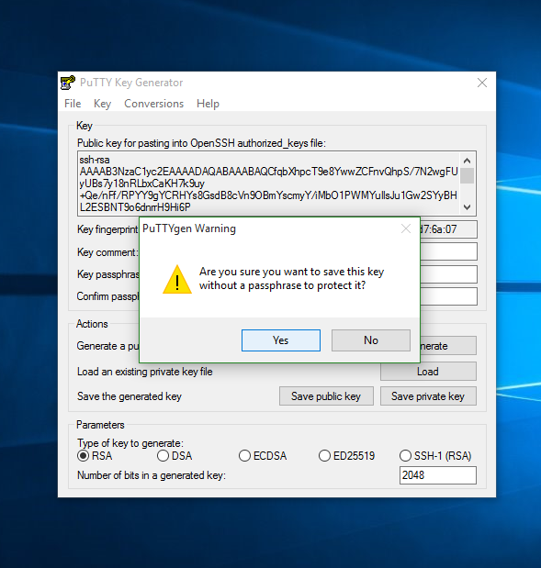

Then open PuTTY .

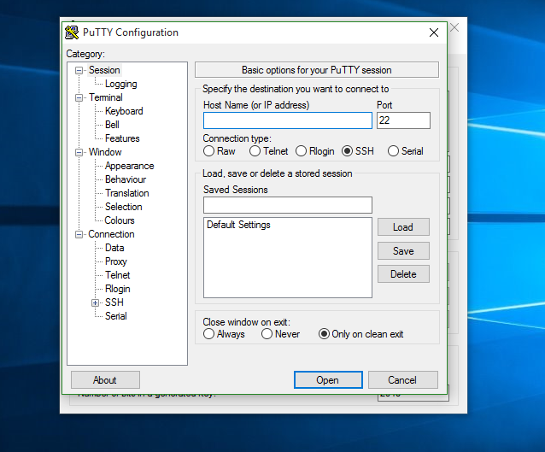

In category list go to Connection>SSH>Auth. And in the text box enter the place that your key is downloaded (private key path) using browse button. And select open.

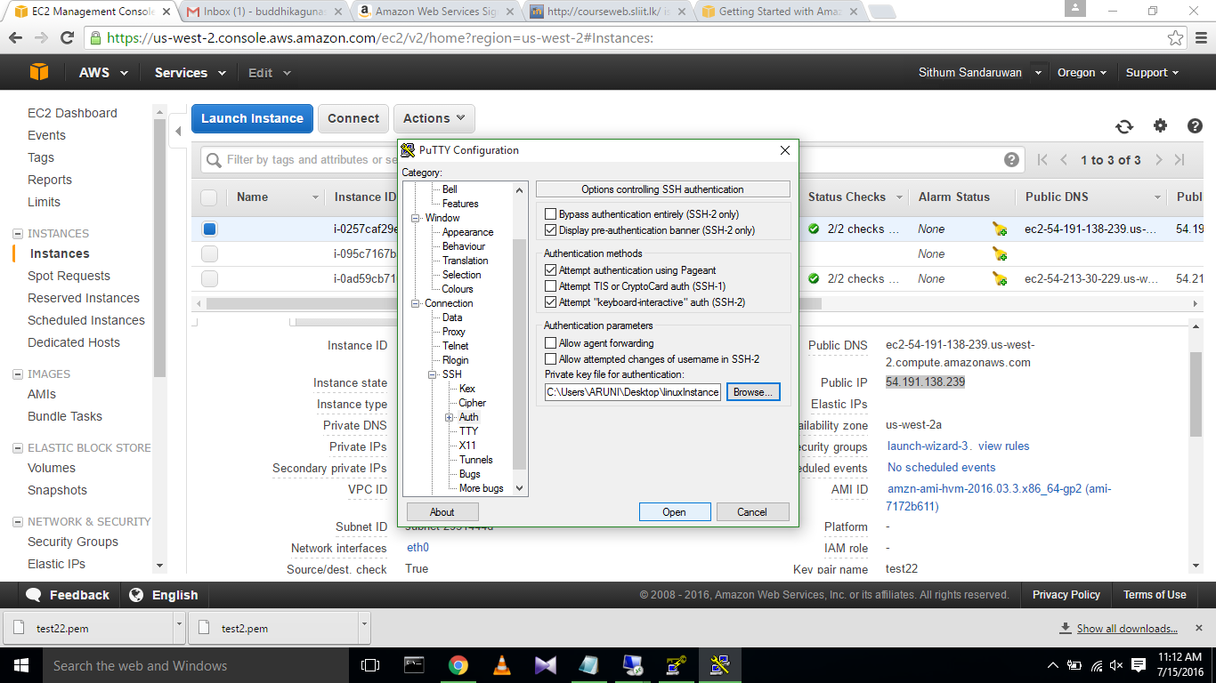

Finally you will get a command prompt and set user name as ec2-user.

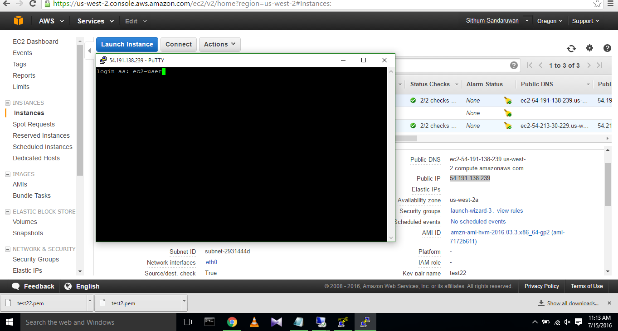

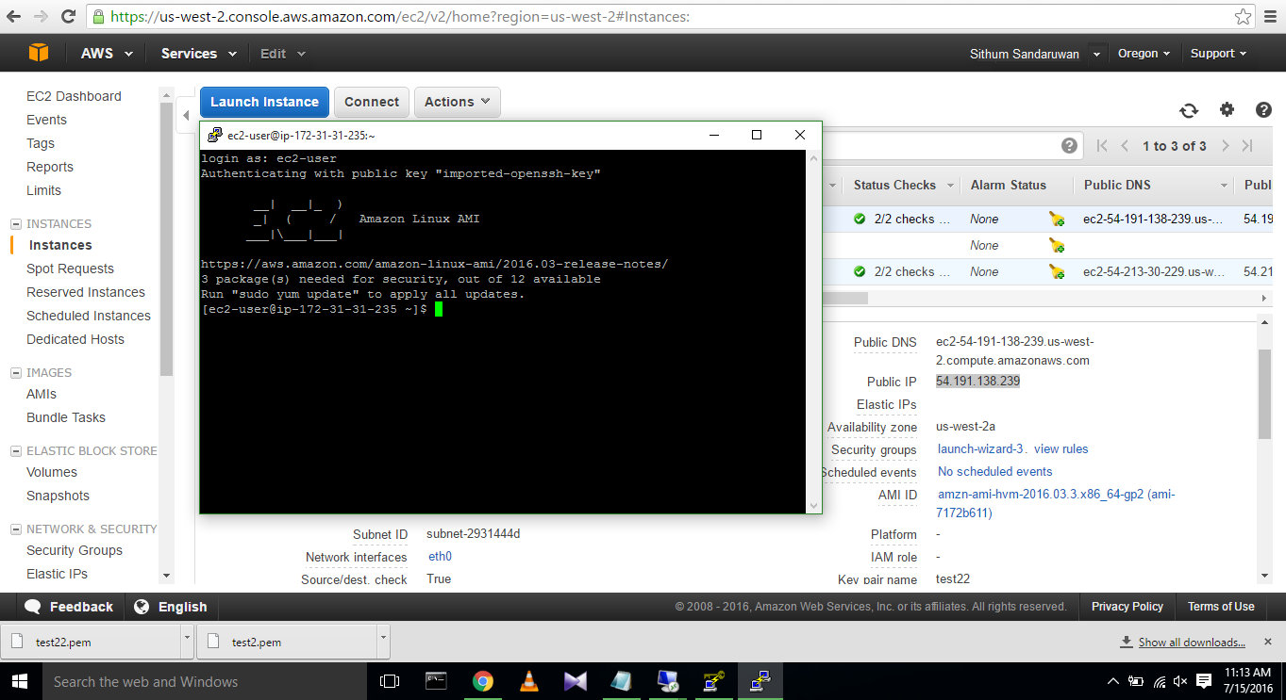

Then you can check weather Linux commands are running on that terminal.

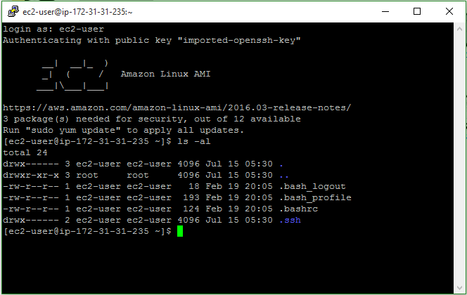

* **References:**

<http://docs.aws.amazon.com/AWSEC2/latest/UserGuide/EC2_GetStarted.html>